P(z_{i}^{(t)}=j) \propto p_j^{(t-1)} \prod_{k=1}^{d} \frac{1}{(\sigma_{l_{jk}}^{(t-1)}+\sigma_{r_{jk}}^{(t-1)})}

\times \left\{\begin{matrix}

\exp \begin{bmatrix}

-\frac{(X_k-\mu_{jk}^{(t-1)})^2}{2(\sigma_{l_{jk}}^{(t-1)})^2}

\end{bmatrix}\ if\ X_k\ <\ \mu_{jk}^{(t-1)} \\

\exp \begin{bmatrix}

-\frac{(X_k-\mu_{jk}^{(t-1)})^2}{2(\sigma_{r_{jk}}^{(t-1)})^2}

\end{bmatrix}\ if\ X_k\ >\ \mu_{jk}^{(t-1)} \\

\end{matrix}\right.

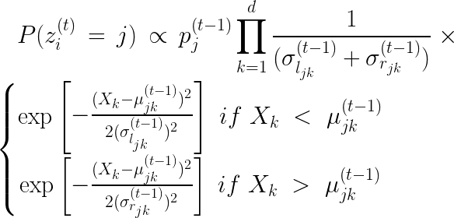

1d to 2d Gaussian

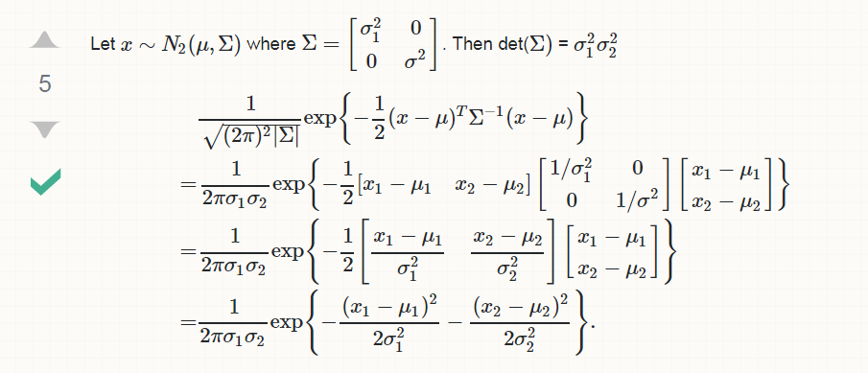

\scalebox{.6}{$= \prod_{i=i}^N \prod_{j=1}^M\frac{P(X_i|\mu_j^{(t)},\sigma_{lj}^{(t)},\sigma_{rj}^{(t)})\textit{N}_d(\mu_j^{(t)}|\eta,\Sigma)\textit{N}_d(\sigma_{lj}^{(t)}|\tau,\Sigma)\textit{N}_d(\sigma_{rj}^{(t)}|\tau,\Sigma)\textit{N}_d(\mu_j^{(t-1)}|\mu_j^{(t)},\Sigma)\textit{N}_d(\sigma_{lj}^{(t-1)}|\sigma_{lj}^{(t)},\Sigma)\textit{N}_d(\sigma_{rj}^{(t-1)}|\sigma_{rj}^{(t)},\Sigma)}

{P(X_i|\mu_j^{(t-1)},\sigma_{lj}^{(t-1)},\sigma_{rj}^{(t-1)})\textit{N}_d(\mu_j^{(t-1)}|\eta,\Sigma)\textit{N}_d(\sigma_{lj}^{(t-1)}|\tau,\Sigma)\textit{N}_d(\sigma_{rj}^{(t-1)}|\tau,\Sigma)\textit{N}_d(\mu_j^{(t)}|\mu_j^{(t-1)},\Sigma)\textit{N}_d(\sigma_{lj}^{(t)}|\sigma_{lj}^{(t-1)},\Sigma)\textit{N}_d(\sigma_{rj}^{(t)}|\sigma_{rj}^{(t-1)},\Sigma)}$}